|  |
| --- |
|  |
| Obstacle detector and distance measurement  Akash kumar 19BCG1069 |
| |  |  |  | | --- | --- | --- | | Swarup Deb | 11/3/19 | 19BCG1077 | |

**CIRCUIT DIAGRAM**: 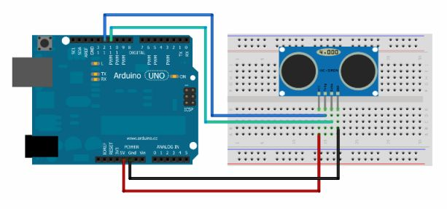

**Theory:**

**CONCEPT USED**:

1. An Ultrasonic sensor is a device that can measure the distance to an object by using sound waves
2. It measures distance by sending out a sound wave at a specific frequency and listening for that sound wave to bounce back. By recording the elapsed time between the sound wave being generated and the sound wave bouncing back.
3. It is possible to calculate the distance between the sonar sensor and the object

**LEARNING & OBSERVATION**:

1. I learned how An Ultrasonic Sensor works and its connections with Arduino using breadboard.
2. I learned about how Ultrasonic Sensor real life Applications.
3. When the wave hits obstacle it reverts and the distance between obstacle and the sensor is calculated.

**PROBLEMS & TROUBLESHOOTING**:

1. There was problem while uploading code to Arduino, as the port selected was incorrect hence, to solve it I change the PORT. 3
2. The sensor was not detecting the object as there was error in code. So, code was debugged.
3. To select the right port and type of Arduino.

**PRECAUTIONS:**

The problems faced by me while doing this task are:

1. Arduino Board should be kept at dry place.
2. Correct Board/Port is to be selected.
3. All connections should be tight. IV. No objects should be placed in front of sensor.
4. V. The Trigger pin should be connected with pin as Output mode.
5. VI. The Echo pin should be connected with pin as Input Mode.

**LEARNING OUTCOMES:**

1. How the waves are sent and received by sensor when object is detected.
2. Whenever person passes by the waves are bounced back and the whole time taken is T whereas to reach the object it is t/2.
3. Learnt how to make connections between sensor and Arduino using breadboard.